**PriceGuard Project Milestone 3**

**“** Needs Finding**,** Understanding Users and Building Empathy”



|  |
| --- |
| **Section 1 - Needs Finding Report** |

## 1.1 Target Population

PriceGuard aims to cater to a wide range of users who prioritize budget-conscious and informed shopping. The primary demographic involves members from low budget and medium budget households who are responsible for grocery shopping. These include:

* Students with limited finances and are living independently. These young individuals often have to juggle financial costs of their education, living costs and grocery expenditure on their own, often on a tight budget
* Middle and Lower class families who often have a limited budget and are always aiming to optimize household expenses without compromising on necessities.

## 1.2 Study Participants

#### **Participant A:**

A retired air force officer in his mid 50s, responsible for managing his family of five house household expenses. With a background in the armed forces, he has a structured, systematic approach towards handling any situation, which includes budgeting and financial management. His background as an engineer within the air force also means he has a strong hold over his technical expertise in technology, keeping up to date with the latest technological trends

#### **Participant B:**

A school teacher in her mid-forties who handles budgeting and household expenses for her family. With fair technical expertise, she represents the target audience that, although familiar with digital tools, may not be entirely tech-savvy. As a mother of two, she is mindful of budgeting and making informed decisions to supply the best to her family. As a working professional, she values time-efficient, no nonsense methods to optimize spending, making her a key representative of the target audience.

#### **Participant C:**

A hostelite student in her early twenties, managing her grocery expenses on her own. She’s comfortable with digital tools but prefers simple, user-friendly solutions. Living on a tight budget, she’s careful about her spending and always looks for affordable and convenient options. With a busy schedule balancing studies and daily tasks, she values anything that saves time and effort. This makes her a relatable example of someone who values efficient and straightforward ways to manage expenses effectively.

#### **Participant D:**

A young man in his twenties, living with his parents and occasionally handling small grocery errands for items needed immediately. While his parents take care of the major grocery shopping, he often steps in for last-minute necessities. Preferring convenience, he shops at nearby stores but notices inconsistent item availability. With a practical approach, he values efficient solutions that could help track spending and compare prices—making him a relatable example of someone adapting to grocery budgeting amidst inflation.

#### **Participant E:**

A student in their twenties who assists their guardians in grocery shopping. They are responsible for helping their guardian manage the groceries and use different ways to do so. They also are responsible for their own personal items and spend their pocket money on such purchases.

#### **Participant F:**

A student in their twenties who assists their guardians in grocery shopping. They are responsible for helping their guardian manage the groceries and use different ways to do so. They are always looking for ways to find the best deals and make grocery shopping more efficient, but sometimes struggle with keeping track of changing prices and managing expenses effectively.

#### **Participant G:**

A 18-year-old student who, despite his young age, holds primary responsibility for grocery shopping in his household. Representing the younger segment of budget-conscious consumers, he manages daily shopping tasks based on his experience and intuition rather than formal planning tools. His situation reflects a unique intersection of limited financial resources and early responsibility, making him an important voice for understanding how teens and young adults cope with price fluctuations and household needs without structured support systems.

#### **Participant H:**

A 27-year-old school teacher and mother of one child who manages grocery planning and shopping on a tight monthly budget. As a full-time working professional with limited time—especially during busy months like Ramadan—she represents a core segment of PriceGuard’s target audience: working mothers who value structure, prioritize needs carefully, and seek practical solutions to overcome inflation-related challenges. Despite relying on traditional budgeting methods, she has shown openness to adopting digital tools if they simplify price comparison and save time.

## 1.3 Findings from the study

#### **Overview of key insights**

The interviews revealed that grocery shoppers, particularly those responsible for household budgeting face significant challenges due to constantly fluctuating prices and lack of reliable price taking tools. Participants emphasized the difficulty of staying within budget, the unpredictability of costs and the effort required to compare prices across stores.

1. Concern of price fluctuation.
2. Participants relied on manual methods such as register and pen, receipts or excel sheets to keep track of their expenses. This tends to be frustrating, arduous and time-taking.
3. Interviewees expressed interest in an app that provides budget tracking and real time price alerts and comparison.
4. We also learned how users seem interested in deals and discounts but are unaware of them due to their specific store’s lacking or are uninformed of offers of other stores.
5. Some interviewees seemed to be interested in foreign products and desired to track inflation effects on such products.
6. Hard to track spending over time.
7. Lack of price tags in stores sometimes leads to budget overruns.

#### **Identified user needs**

1. Price Comparison and Tracking.
2. Predictive Price Trends.
3. Budgeting Assistance.
4. Store Specific deals/discounts and alerts.
5. Predict Fluctuations on Imported Products.
6. Budget dashboards with warnings before overspending.
7. Receipt scanning to auto-categorize spending.
8. Updates on item availability.
9. A centralized digital solution

#### **Current practices and challenges**

1. Check online listings.
2. Relying on word of mouth through asking family friends. Participant B mentioned a whatsapp group chat where her friends post recent discounts and price updates.
3. Tracking prices through manual means, often through a register and pen, or excel sheet. Participants expressed great frustration in how time-consuming and arduous this task can be. According to Participant A, “I end up dreading this task the most”.
4. Some interviewees have started to avoid imported items due to increased priced from inflation.
5. Interviewees also observed increase in necessity-driven consumption and a decrease in wants-based spending,
6. Unexpected price hikes and missing tags disrupt budgets, forcing last-minute trade-offs without centralized tracking.
7. Saves receipt photos to track spending but wants a scanner tool to automate budgeting and price comparisons without extra effort.
8. Manual comparison between stores is time-consuming and sometimes limited by transportation or store access.
9. Shopping decisions are often made using habit, intuition, or prior experience rather than real-time data.
10. Users often experience **budget overshoots**, especially when unexpected price spikes occur at the time of shopping.

#### **Supporting quotes and anecdotes from participants**

*“Manually keeping track on an excel sheet is a nightmare! I don’t know what’s worse, the shopping part or spending hours with a calculator accounting and budgeting”* - **Participant A**

***“****Price Fluctuation is too unpredictable and incredibly frustrating”*

**- Participant A**

#### 

*“Oftentimes, I realise after checkout that I could have saved money elsewhere. It’s beyond annoying”*

**-Participant B**

***“****In my 4 years of hostel life, I could buy more with my budget than before—now I’m constantly adjusting.”*

**- Participant C**

***“****If there was a tool to compare stores, I’d use it. Why drive to Punjab Cash & Carry if Save Mart has honey for 1,000 rupees less?.”*

**- Participant D**

***“****A lot of times we let go of the purchases we make for our own joy as the necessities themselves have become very expensive.”*

**- Participant E**

***“****There aren't any deals on grocery items, almost never, in the store where we shop from.”*

**- Participant F**

*“I usually shop nearby, but if the prices are too high, I visit other stores—even if they’re far.”*

**- Participant G**

*“Sometimes the prices terrify me. I plan everything but it still goes out of control.”*

**- Participant H**

## 1.4 implications for study design

**New requirements discovered**

* What if for students, auto generated budget plans and help through ai to figure out a suitable budget rather than manually setting for those who already know what their budget will be>?
* What if users could check real-time prices and store inventory before shopping, with instant budget alerts during checkout—rather than just tracking spending after the fact?
* What if users need automated budget adaptation that responds to real-time price shocks, not just static comparisons? The interview revealed mental budgets often fail when prices spike unexpectedly ("I had to return items at checkout").
* Users may need more than just static price comparisons — they may benefit from an **automated budget assistant that adjusts in real-time** to price shocks. Interviews revealed that mental budgets often fail under unexpected price spikes, leading users to cut items at checkout or shrink quantities.

**Constraints Identified:**

* Must work for users with minimal tech skills (no complex setups).
* Must adapt to unreliable local data (like missing items or messy receipts), pushing for simple, offline-capable tools over advanced dashboards.
* Retailer APIs are fragmented, and hyper-local price volatility (like Rs. 200 noodle price gaps between stores) demands live data we can't yet scrape reliably.
* Users may have **limited digital literacy** or prefer traditional methods; interface must be highly intuitive
* Physical access to multiple stores is not always feasible, especially with rising fuel costs and time limitations.

## 1.5 research methods & evidence

#### **Initial Affinity Wall:**

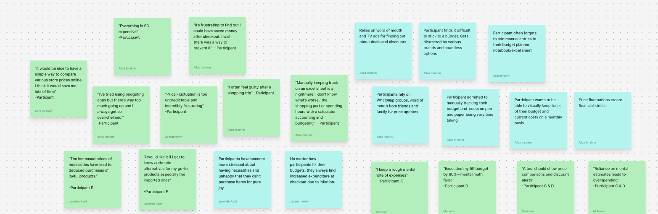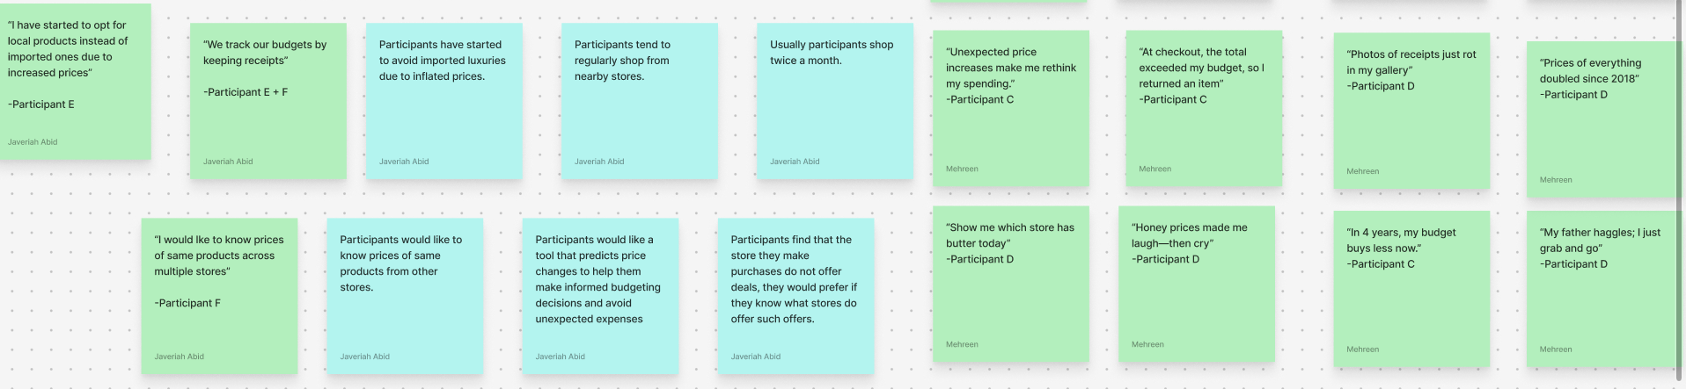

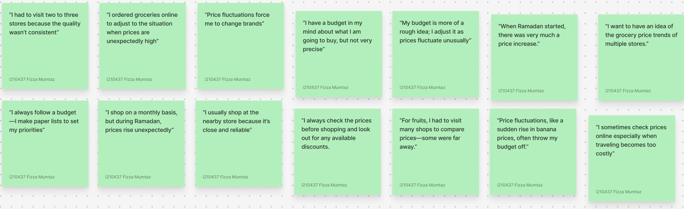

#### 

#### **Final Affinity Wall:**

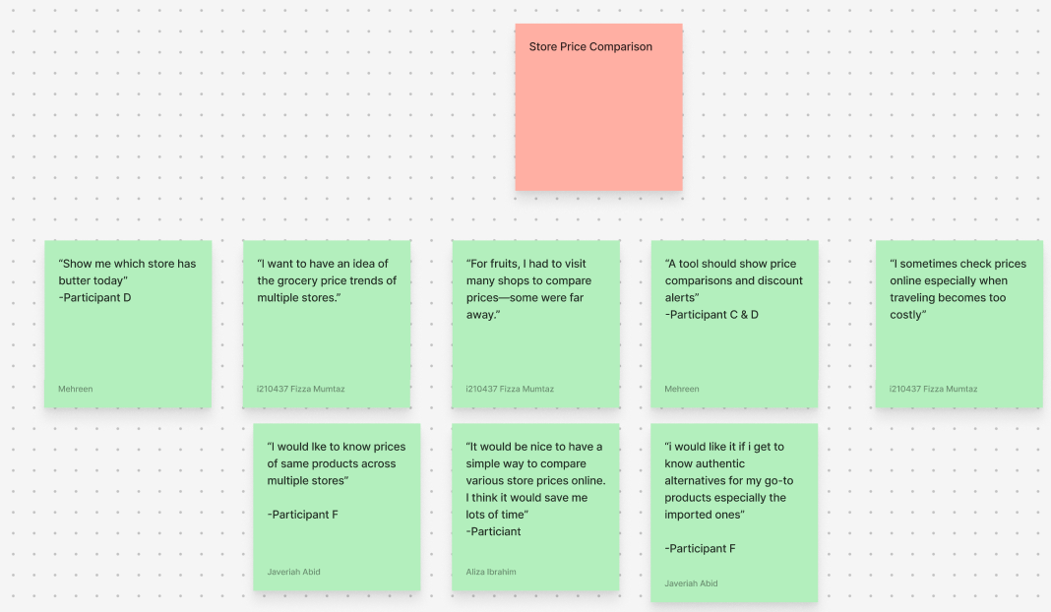

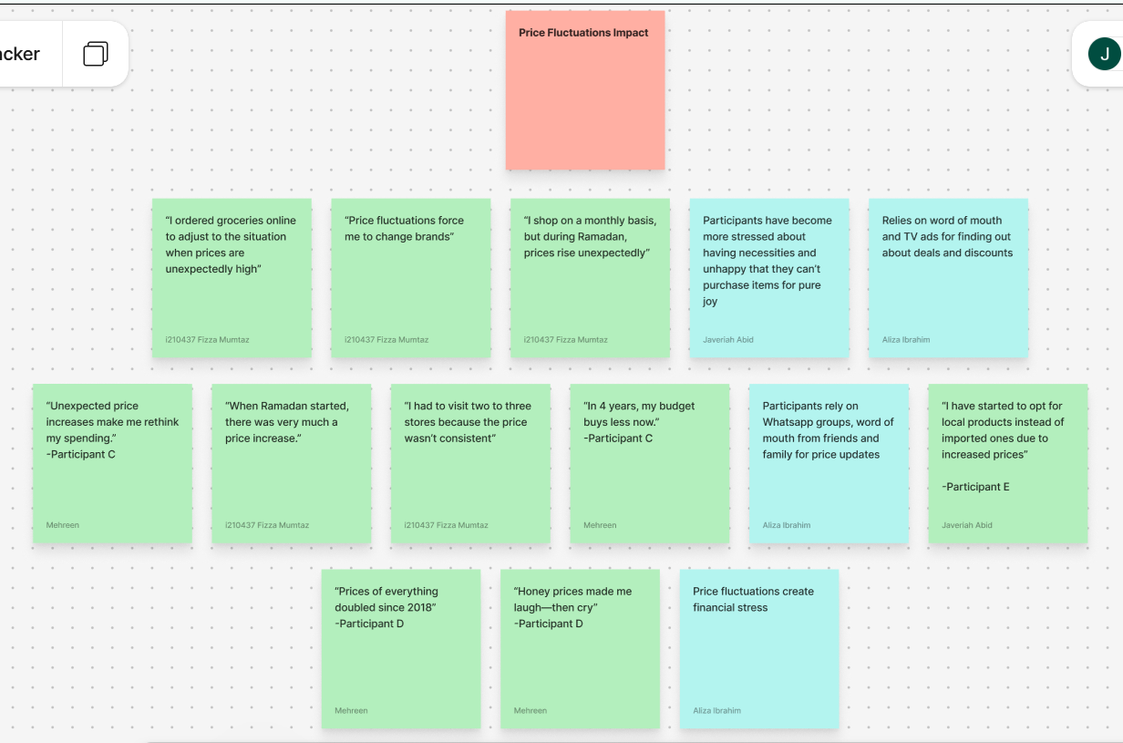

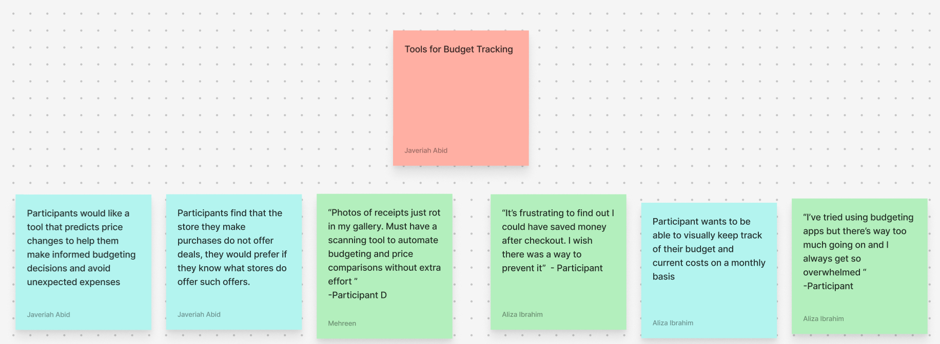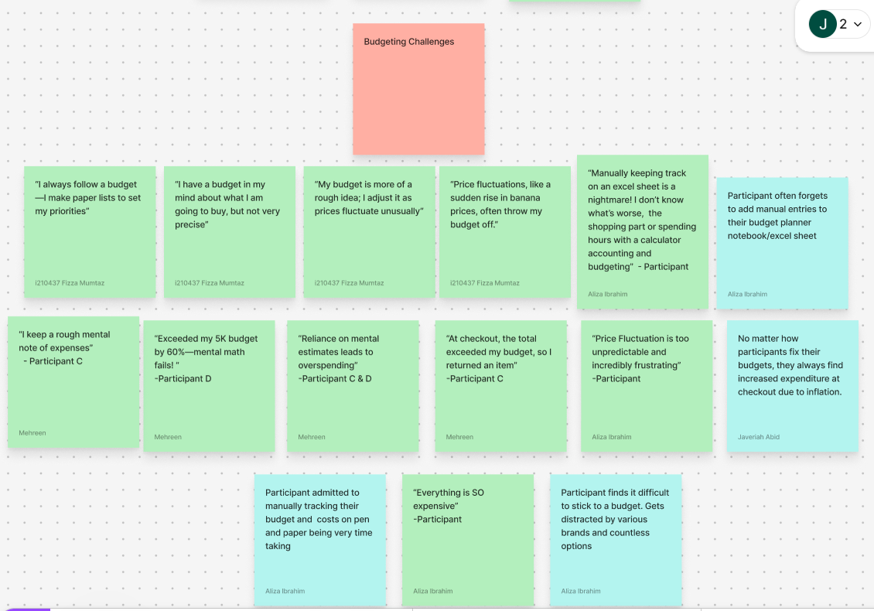

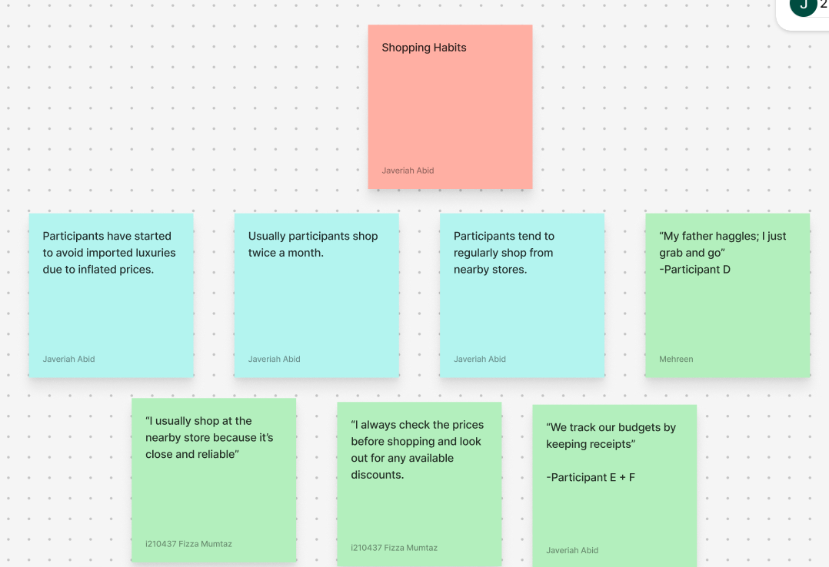

## 1.6 interviews evidence

Visit the link where all the recordings to our interviews are stored for evidence: <https://drive.google.com/drive/folders/1IOJu9E7jBFaQQf8KCsEzKKKuTy5Y1C-r?usp=drive_link>

|  |
| --- |
| **Section 2 - Empathy mapping and personas** |

## 2.1 empathy maps

#### **Participant A**

#### 

#### 

#### 

#### 

#### 

#### **Participant B**

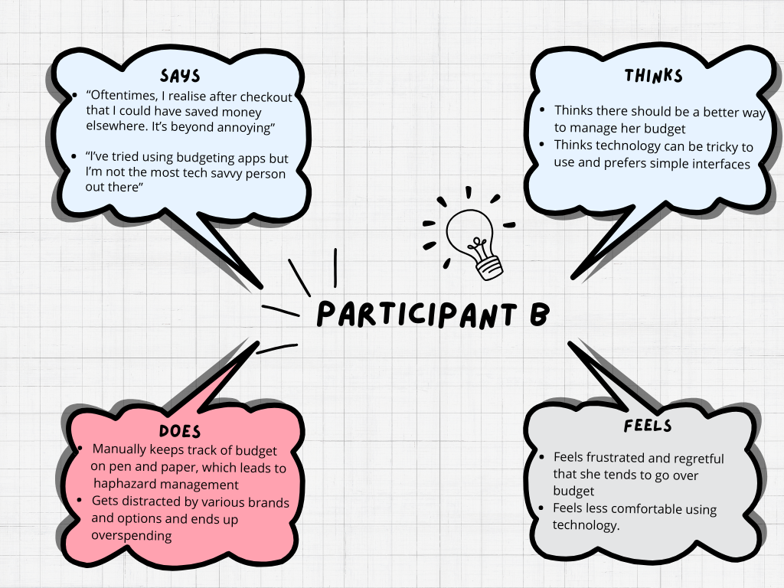

#### **Participant C**

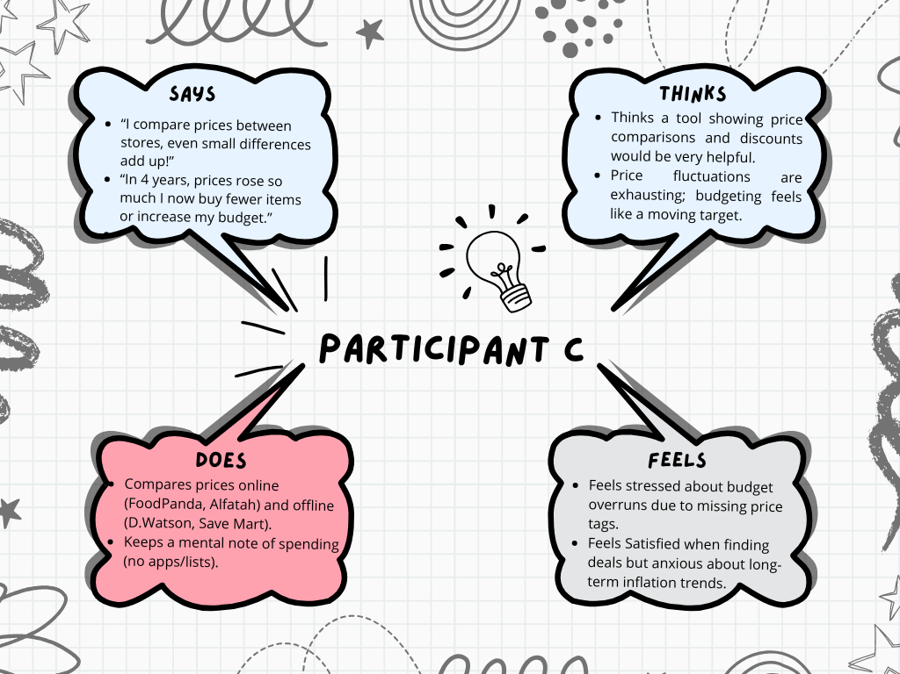

#### **Participant D**

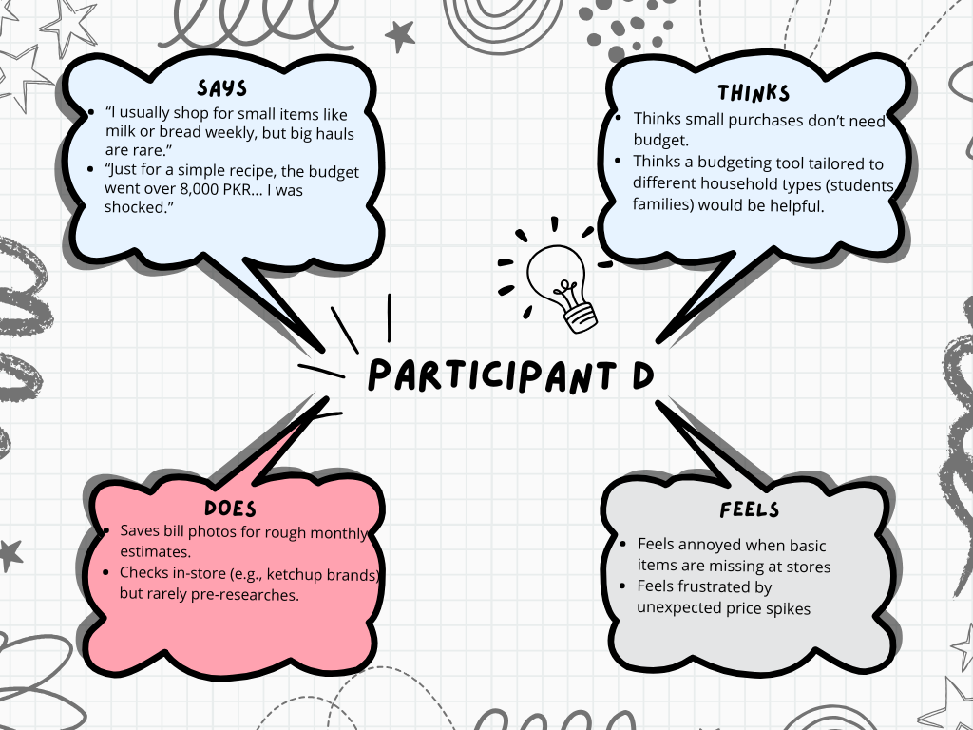

#### **Participant E**

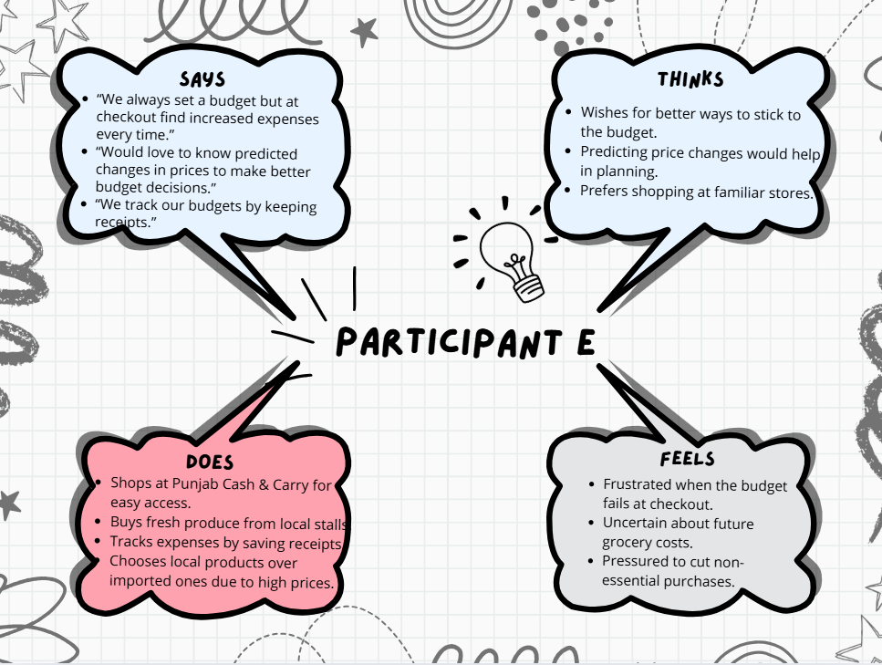

#### **Participant F**

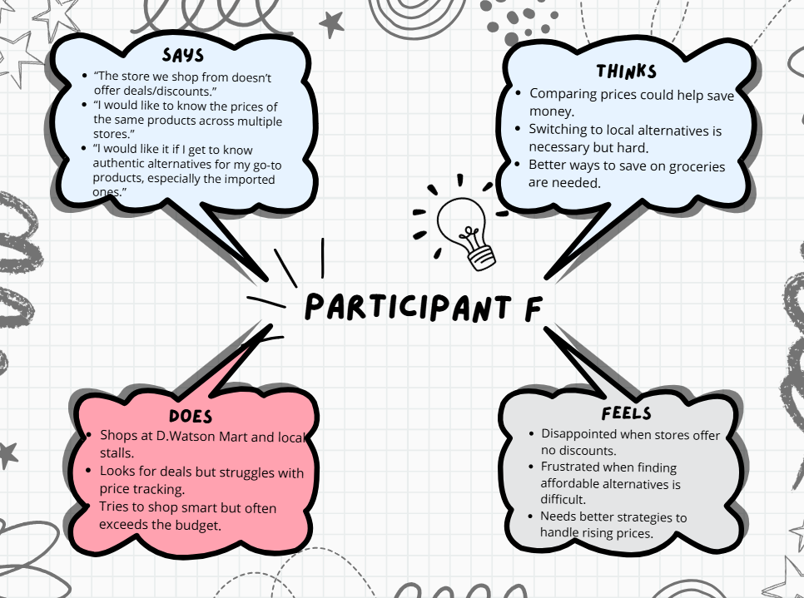

#### **Participant G**

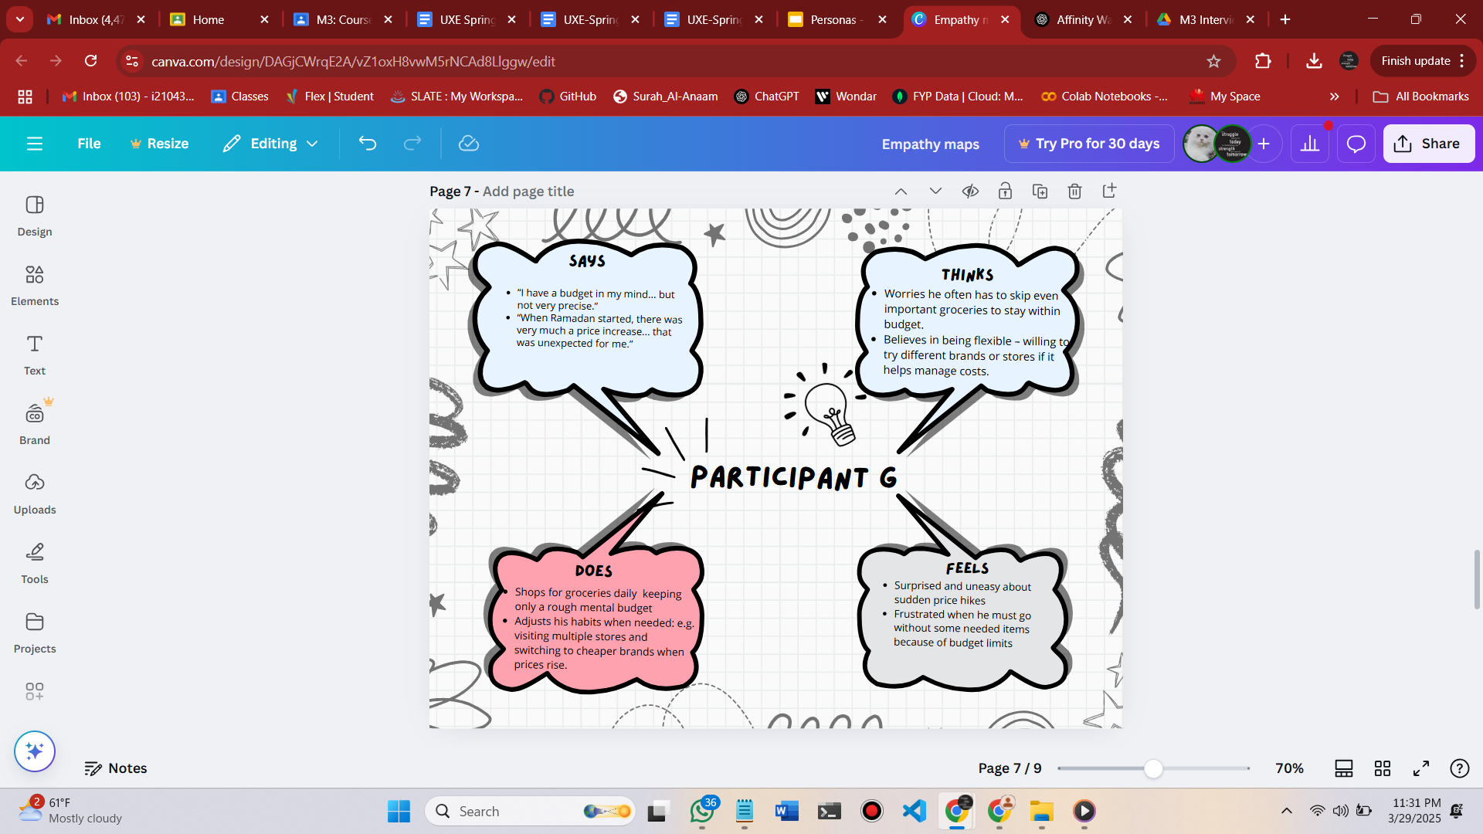

#### **Participant H**

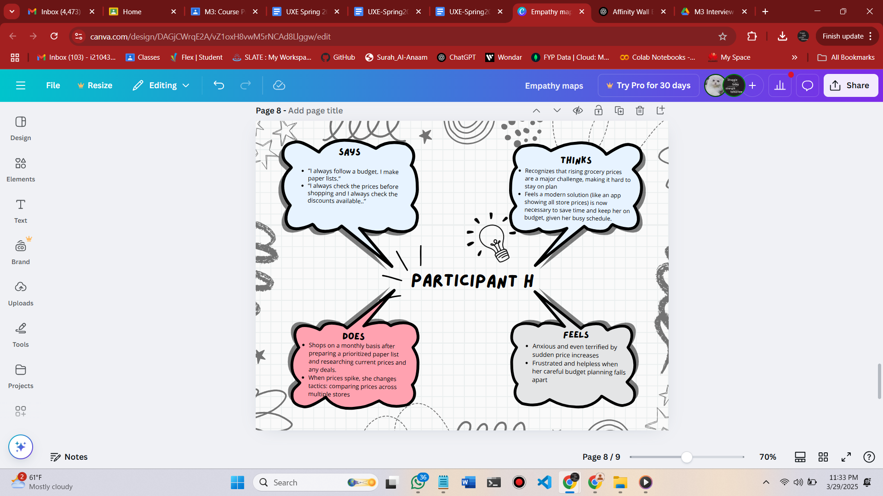

## 2.2 personas

**Persona 1**

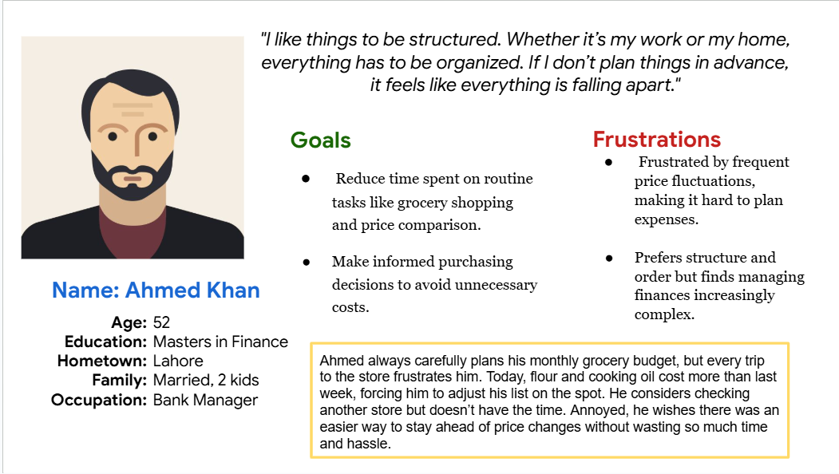

**Persona 2**

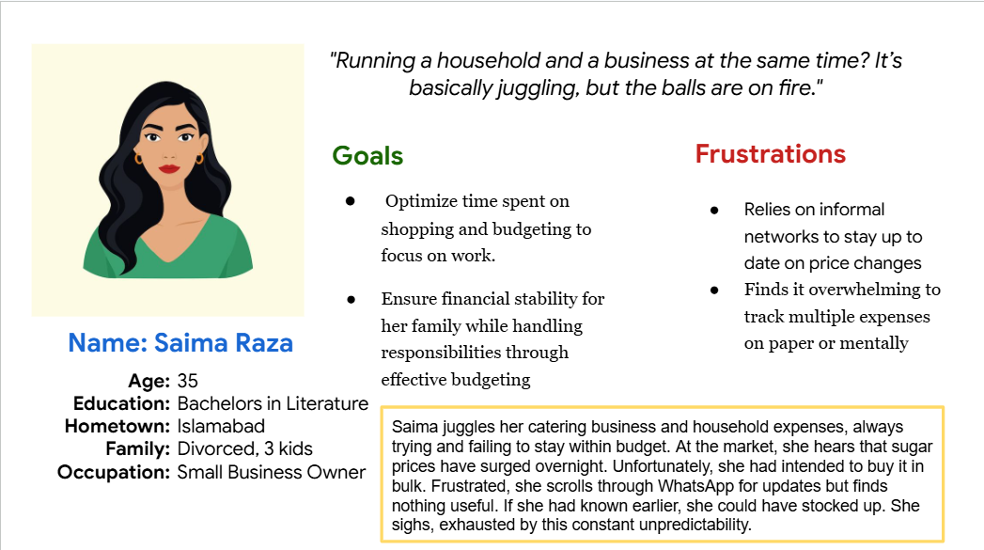

**Persona 3**

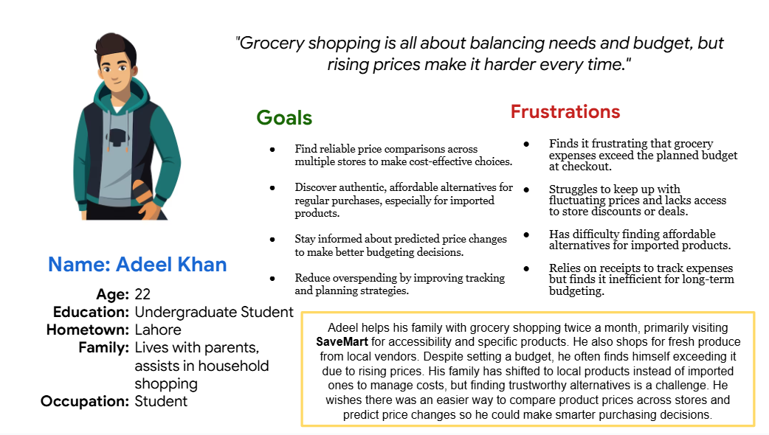

**Persona 4**

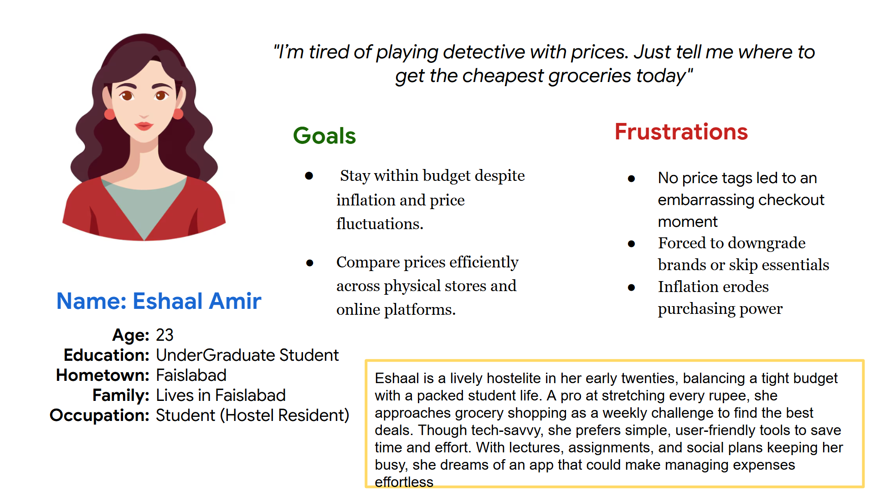

## 2.3 reflection on bias

#### **Javeriah Abid**

I observed that I seemed to have a bias towards fruits and vegetables in groceries as compared to other groceries during the interviews. I redirected the interview direction towards this aspect of groceries however I caught on to this quickly and tried to keep the interview as neutral and generic as possible. Later on I observed the interview going quite fruits/vegetables oriented, then I started to lead it on other groceries as well.

#### **Mehreen Israr**

During the interviews, I observed a tendency to disproportionately focus on personal care items like shampoo while neglecting other grocery categories. This bias likely emerged from my subconscious assumptions about participants' priorities. Upon recognizing this imbalance, I made a conscious effort to redirect the conversation toward broader grocery purchasing habits, using more neutral prompts such as asking participants to walk me through their entire grocery lists. I also began cross-checking responses to ensure diverse items were being discussed without undue influence from my questioning. This experience highlighted the importance of maintaining awareness during interviews and using structured, open-ended questions to minimize unintended focus on specific products.

#### **Fizza Mumtaz**

I think some subtle bias may have influenced my study. Since the participants were familiar to me, they might have felt inclined to give more agreeable or positive responses. Also, some of my questions may have unintentionally directed their answers by focusing on budgeting and price-checking behaviors. Finally, both participants were already responsible for grocery shopping, so the study might not fully capture the experiences of those who are less involved in that role.

#### **Aliza Ibrahim**

I think some bias may have come from participants' strong preferences for specific stores or branded items. These personal habits may have influenced their responses, especially when discussing price comparisons or switching behavior. For example, loyalty to a familiar store or brand could make them less open to trying cheaper alternatives, which may have shaped how they viewed budgeting challenges or solutions.

## Appendix

**HIGH-LEVEL goals**

Our goal for this study is to understand how users can track grocery prices, manage their budgets, and make financial decisions for effective purchase in order to reduce the impact of inflation.

Questions:

* *How do grocery shoppers currently track prices and manage budget for groceries?*
* *What problems do grocery shoppers face when tracking price changes?*
* *What features would help grocery shoppers make smarter and cost-effective grocery choices?*
* *Why do grocery shoppers track prices the way they do?*

**recruiting criteria and strategy**

## **Recruitment criteria**

Participants will be selected from the target audience mentioned prior. These include:

* People who are on a tight budget and frequently monitor grocery expenses and are always looking for ways to save grocery expenses.
* Parents, guardians, or household help who handle and manage grocery purchases.
* Students living independently for example, ones living in hostels or shared apartments.
* People who like to stay responsible of the expense they spend and the quality of food they can achieve with reasonable prices.

## **Recruitment strategy**

We plan to conduct interviews upon several platforms to ensure diversity and maximum audience coverage. Here is a list of those strategies:

* Online Surveys & Social Media Outreach – use the digital platform to survey and collect objective information for as much diversity as possible.
* University Outreach – engage with hostelites that manage their own groceries.
* Household Engagement – communicate with parents/guardians or those who manage groceries for the house and figure their pain points.
* Low-Budget Households Outreach – speak to suffering households that are most victim of inflation for a better understanding.
* In-Person Interviews & Focus Groups – in-person interviews to collect subjective and in-depth information.